HEXAWARE - ASSIGNMENT 4

COURIER MANAGEMENT SYSTEM

NAME : SRINATH N S S

TASK 2 : Select , Where

1. List all customers:

USE ASSIGNMENT

SELECT \* FROM Users;

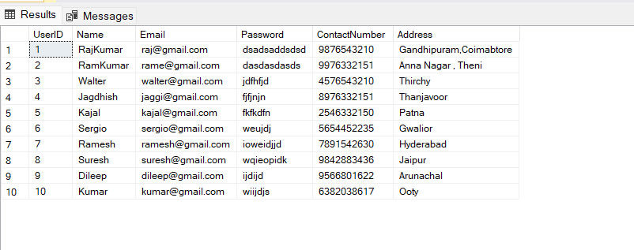

1. List all orders for a specific customer:

SELECT \* FROM Courier

WHERE SenderName = 'SRINATH';

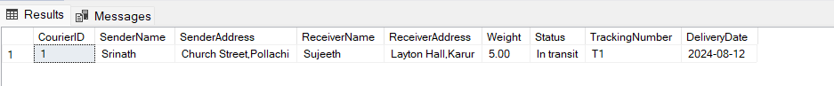

1. List all couriers:

SELECT \* FROM Courier;

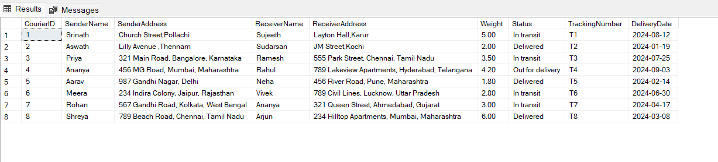

1. List all packages for a specific order:

SELECT \* FROM Courier WHERE TrackingNumber = 'T5';



1. List all deliveries for a specific courier:

SELECT \* FROM Courier

WHERE Courier.CourierID = 3;



1. List all undelivered packages:

SELECT \* FROM Courier WHERE Status != 'Delivered';

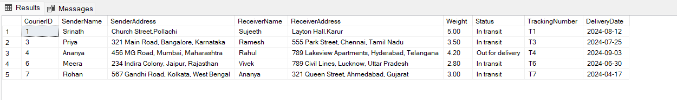

1. List all packages that are scheduled for delivery today:

SELECT \* FROM Courier WHERE Status = 'Out for Delivery';



1. List all packages with a specific status:

SELECT \* FROM Courier WHERE Status != 'Out for Delivery' and Status != 'Delivered';

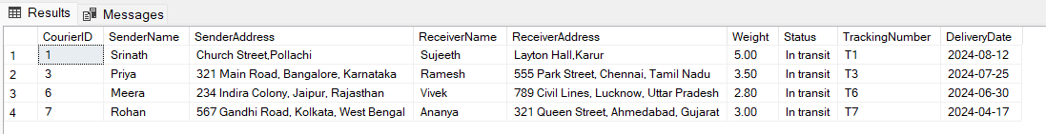

1. Calculate the total number of packages for each courier.

SELECT CourierID, COUNT(\*) AS TotalPackages

FROM Courier

GROUP BY CourierID;

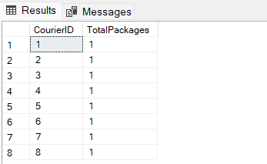

1. Find the average delivery time for each courier

SELECT CourierID, AVG(DATEDIFF(day, DeliveryDate, GETDATE())) AS AverageDeliveryTime FROM Courier

GROUP BY CourierID

HAVING AVG(DATEDIFF(day, DeliveryDate, GETDATE())) >= 0;

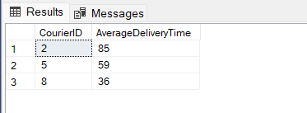

11. List all packages with a specific weight range:

SELECT \* FROM Courier WHERE Weight BETWEEN 3 AND 4;

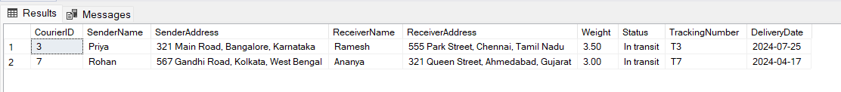

1. Retrieve employees whose names contain 'John'

SELECT \* FROM Employee WHERE Name LIKE '%John%';

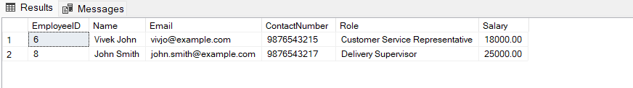

13. Retrieve all courier records with payments greater than $50.

SELECT \* FROM Payment WHERE Amount > 50.00;

